
AMERICAN INTERNATIONAL UNIVERSITY-BANGLADESH
Faculty of Science and Technology
Department of Computer Science
CSC 3215: Web Technologies

Semester: Summer 2025-26 | Group No:08 |  | Section: | K

Group Members:
SL. | Student ID | Name | Role | Signature
41 | 24-56849-1 | Md. Ashikur Rahman Mirza | Group Leader
37 | 24-56803-1 | Md. Mostafizur Rahman | Member
35 | 24-56776-1 | Shahed Bhuiyan Rony | Member
40 | 24-56826-1 | Shajia Afrin | Member
Project Title
Paw Care – Pet Shop and Veterinary Service Management System
Short Description
Paw Care is a web-based pet shop and veterinary service management system designed to simplify pet-related services through a single online platform. The system allows customers to browse pets and pet products, place orders, book veterinary appointments, and track deliveries. Administrators can efficiently manage inventory, users, orders, and business operations, while veterinary doctors can organize appointments and maintain pet medical records. The system aims to provide a secure, user-friendly, and efficient digital solution for modern pet care businesses.
Introduction
The pet care industry is growing rapidly, and many pet owners now expect convenient online services for purchasing pets, buying pet products, and accessing veterinary care. However, many pet shops still rely on manual record keeping or disconnected systems, making it difficult to manage inventory, customer orders, appointments, and business operations efficiently.
Paw Care is a web-based management system developed to provide an integrated digital platform for pet shops and veterinary services. The system enables customers to explore available pets and products, place online orders, schedule veterinary appointments, and manage their accounts from anywhere. At the same time, administrators can monitor business activities, manage inventory, oversee customer orders, and maintain overall system operations.
By combining pet shop management and veterinary services into a single web application, Paw Care improves service quality, reduces manual work, enhances data organization, and provides a better experience for both business owners and customers.

Background Study
In recent years, web-based business management systems have become increasingly popular because they provide faster access to information, better data management, and improved customer experience. The pet care industry is also adopting digital solutions to simplify business operations and enhance customer satisfaction.
Traditional pet shops often maintain customer records, inventory, veterinary appointments, and sales manually or through standalone desktop applications. These approaches may lead to data redundancy, inefficient workflows, and limited accessibility.
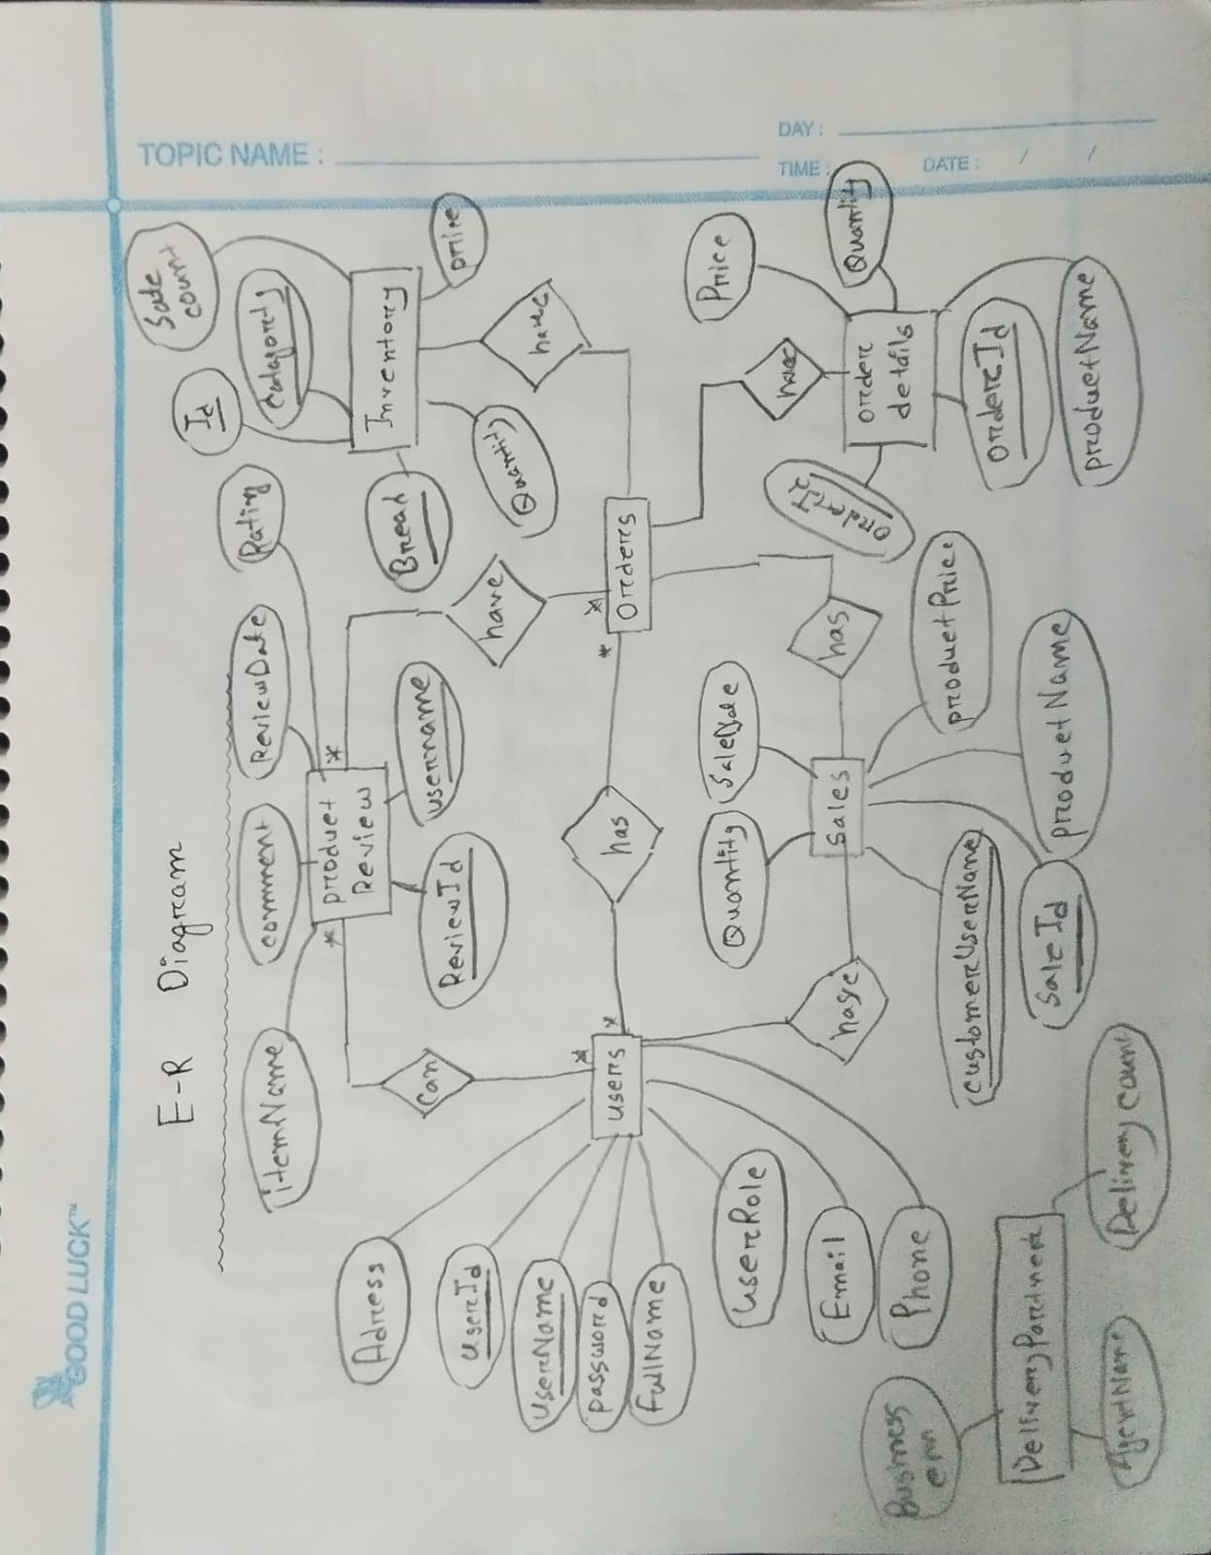
Paw Care is proposed as a web-based solution that integrates pet shop operations, veterinary services, and delivery management into a single platform. By utilizing modern web technologies such as HTML, CSS, JavaScript, PHP, and MySQL, the system offers secure data management, real-time accessibility, and role-based functionalities for different types of users.
ER Diagram

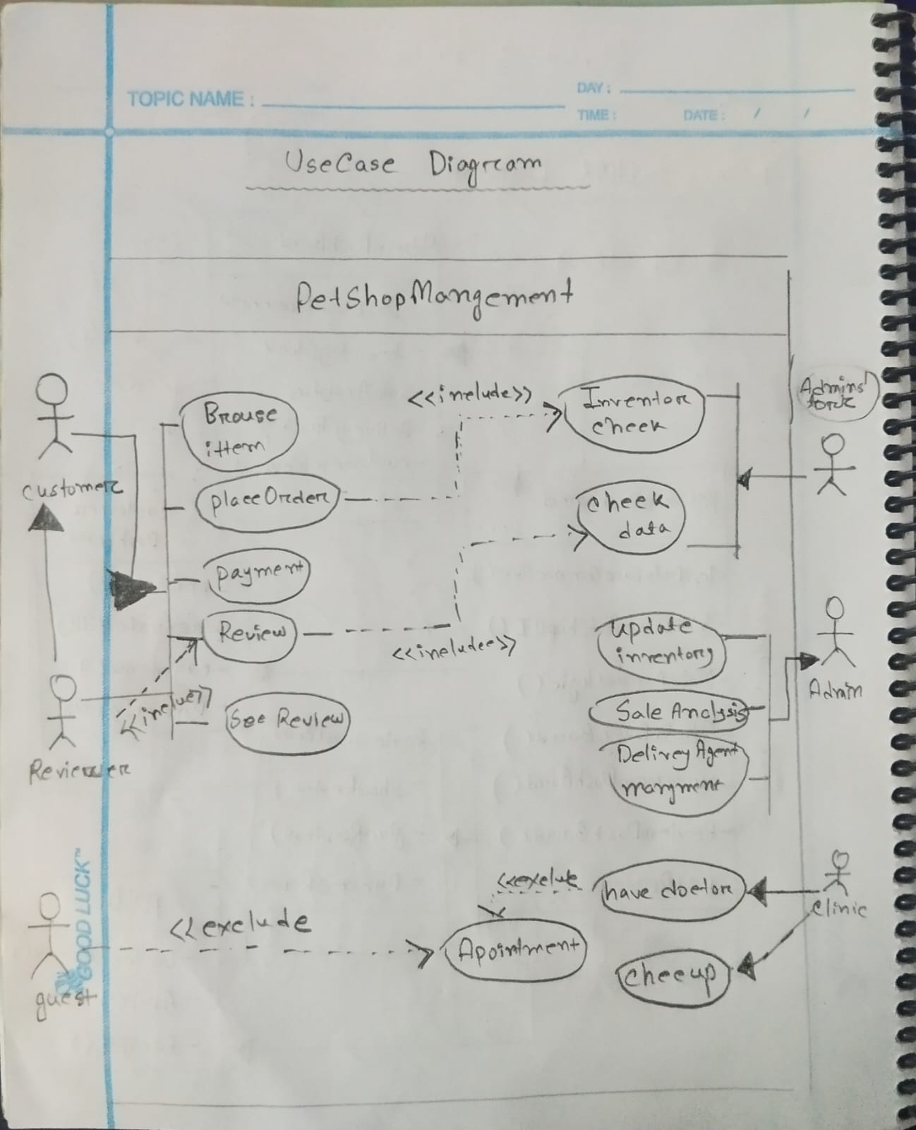
Use Case Diagram

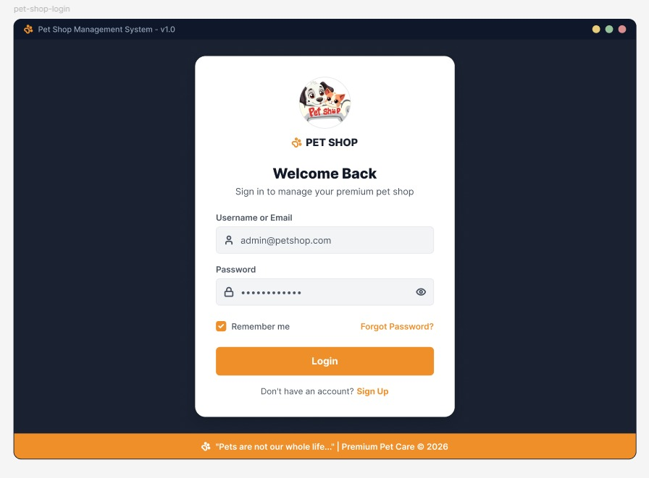
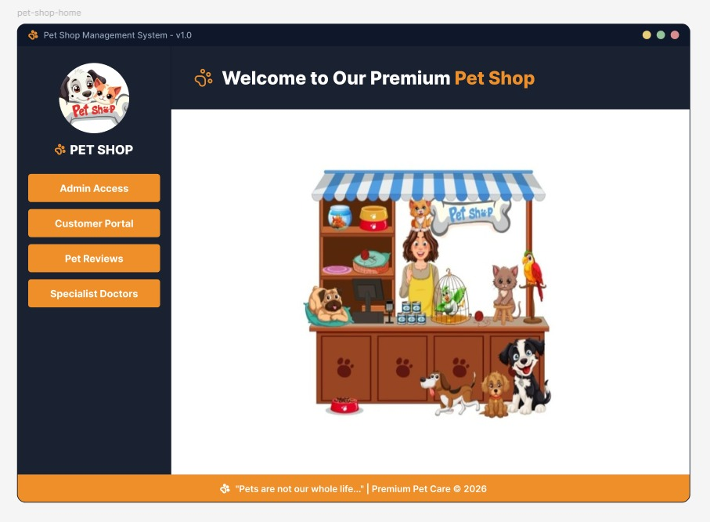
UI (Figma/Sketch)
TYPES OF USERS:
- User1: Administrator
The Administrator manages the overall system, including users, inventory, orders, veterinary services, and business operations.

- User2: Customer
Customers can browse pets and products, purchase items, book veterinary appointments, and track their orders.

- User3: Veterinary Doctor
Veterinary doctors manage appointments, maintain pet medical records, and provide consultation services.

- User4: Delivery Agent
Delivery agents receive assigned orders, update delivery status, and complete deliveries.

Common Features (Available to All Users)
- Authentication
- Login to the system
- Logout from the system
- User registration
- Account Management
- Change or reset password
- Manage profile information (view, edit, delete)
- Dashboard
- Access a personalized dashboard after login

SPECIFIC FEATURES BY USER TYPE
- Features of User1: Administrator
- Inventory Management: Add, Update, Delete Pets & Products.
- Order & Delivery Management: View Orders, Assign Delivery Agent, Update Order Status.
- User & Business Monitoring: Manage Users, View Reports, Monitor Sales Statistics
- Features of User2: Customer
- Browse & Purchase Pets and Products: Search, Filter, View Details, Add to Cart.
- Veterinary Appointment Booking: Book Doctor Appointment and View Appointment Status.
- Order Tracking & Reviews: Track Orders, View Purchase History, Submit Reviews
- Features of User3: Veterinary Doctor
- Appointment Management: View and Manage Daily Appointments
- Pet Medical Records: Create and Update Pet Health Records
- Treatment History: View Previous Medical History and Consultation Records
- Features of User4: Delivery Agent
- Assigned Order List: View Assigned Deliveries
- Delivery Status Update: Update Order Status such as Out for Delivery and Delivered.
- Delivery History: View Completed Deliveries and Delivery Performance

